26.74: a) 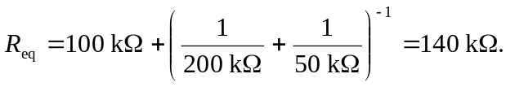
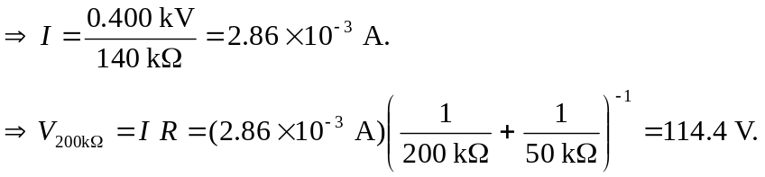
b) 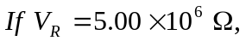 then we carry out the same calculations as above to find
c)

